university of pretoria
Recharge with water level and climatic data
Department of Geology
Muravha Sedzani Elia (28234422)
5/8/2012

Abstract Recharge is an addition of water into the aquifer by means of natural or artificial infiltration. Water budget equation balances groundwater record and accounts the annual recharge to the groundwater resource and is also needful for the management and utilization of water resource in groundwater development programs. Recharge simulation models are globally utilized in hydrological studies to estimate recharge and identify factors that influence recharge. This paper will elaborate on different recharge estimation model, their limitations, requirements and different modeling equations to estimate recharge. The models are divided according to different zones namely; surface water, saturated and unsaturated zone. The paper give a detailed information about the zones and methods used to estimate recharge and some of these methods include saturated water budget models ( HELP3, tank or bucket model), models based on the Richards equation, up scaling of recharge estimates (simple empirical models, power function models, regression techniques and geostatistical techniques), the unsaturated physical models (zero-flux plane method (ZFP), lysimetry and cumulative rainfall departure), the saturated physical models (water balance method and water table fluctuation method) and the surface water physical models (groundwater modelling).

Contents
- Introduction
- Water budget
- Modelling methods
3.1 Unsaturated zone water budget model
3.1.1 Soil water budget models
3.1.1 .1 Tank or budget model
3.1.1.2 HELP3 models
3.1.2 Models based on the Richards equation
3.2 Up scaling of recharge estimates
3.2.1 Simple empirical models
3.2.2 Power function models
3.2.3 Regression techniques
3.2.4 Geostatistical techniques
4. Unsaturated physical models
4.1 Zero-flux plane method (ZFP)
  - Lysimetry
4.3 Cumulative rainfall departure
4.3.1 Limitations
4.3.2 Method ratings
- Saturated physical models
  - Water table fluctuation method
5.2 Water balance method
6. Surface water physical models
6.1 Groundwater modelling
    - Limitations
6.1.2 Data requirements
6.1.3 Model ratings
- Climate impacts on groundwater recharge
- Summary of groundwater recharge estimation methods
- Conclusion
- References
- Introduction
The topographical effects and geological controls such as permeability, climatic factors, precipitation, govern recharge and thus groundwater flow regimes in the aquifer. Recharge is defined as the addition of water to the saturated zone either through natural (e.g. by precipitation) or artificial (e.g. by injection) means and the amount in natural recharge being controlled by factors such as precipitation after runoff, vertical hydraulic conductivity, transmissivity of aquifers and vertical infiltration through vadose zone etc. Recharge cannot be measured directelt, therefore different models and methods to simulate real natural recharge are used to estimate recharge and determine water level fluctuations. Recharge of aquifer take place either by artificial or natural means and different water budget models can be used to estimate recharge. This paper focuses on the recharge techniques to estimate a recharge level of water in the groundwater system and water budget. Water budget is a groundwater equation that balances groundwater record and it accounts the annual recharge to the groundwater resource. Modelling methods such as unsaturated zone water budget models and physical saturated water budget models are thus of greater importance in recharge estimation and the climatic condition involved during recharge.

- Water budget
Water budget is defined as is a groundwater equation that balances groundwater record and it accounts the annual recharge to the groundwater resource (Poehls et al. 2009). Water budget is needful for the management and utilization of water resource in groundwater development programmes (Poehls et al. 2009). There are various procedures that can be used to determine recharge to an aquifer, these include a direct measure of parameters that determine recharge and calculation from hydraulic characteristics and measured potentiometric data (Poehls et al. 2009). The first step of water budget analysis is to select a control volume which can be any earthly volume and in most hydrological studies a control volume can be a soil column that extends from the surface to a certain depth (Healy 2010). The general water budget equation is given by:
P = ET+∆S+R_{off}+D (1.1)
Where:
  - P is precipitation
  - ET is evapotranspiration
  - ∆S is change in water storage in the column
  - R_{off} is direct surface runoff
  - D is drainage out of the bottom of the column

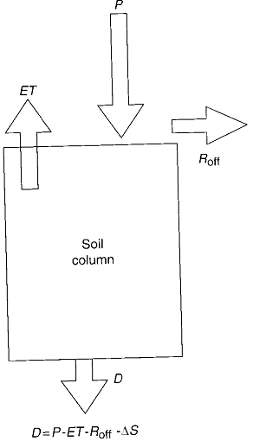
Figure 1 Illustration of 1D water budget (Healy 2010).
The balance in change of storage is given by the difference in the flow into and out of soil column as abbreviated by equation 1.1 (Healy 2010). Drainage out of the bottom of the column is not regarded as recharge until it reaches the water table (Healy 2010). Under saturated and unsaturated zones the water budget equation for a watershed is given by (Healy 2010):
P + Q_{on} = ET + ∆S + Q_{off}
Where:
  - Q_{on} is the surface and subsurface water flow into the watershed
  - Q_{off} is the surface and subsurface water flow out of the watershed
Q_{on} and ET can further be divided into sum of other parameters:
Q_{on} = Q^{sw}_{on} + Q^{gw}_{on} and
ET = ET^{sw} + ET^{gw} + ET^{uz}
Where:
  - Q^{sw}_{on} is the surface water flow into the watershed
  - Q^{gw}_{on} is the groundwater flow into the watershed
  - ET^{sw} is the evapotranspiration of water stored on land surface
  - ET^{gw} is the evapotranspiration of water stored in the saturated zone
  - ET^{uz} is the bare soil evaporation and plant transpiration of water stored in the unsaturated zone.
The change in the water storage is given by (Healy 2010):
∆S = ∆S^{sw} + ∆S^{snow} +∆S^{uz} +∆S^{gw}
Where:
  - ∆S^{sw} is the change in water storage on the surface and plant canopy
  - ∆S^{snow} is the change in water as snow
  - ∆S^{uz} is the change in water storage in the unsaturated zones at depth equal to or less than the zero flux plane.
  - ∆S^{gw} is the change in water storage in the saturated zone
Similarly, the surface and subsurface flow out of the watershed is divided into the sum of the surface water flow out of the watershed and the groundwater flow out of the watershed and the surface water flow out of the watershed can further be divided into a direct runoff (Healy 2010). The direct runoff includes water infiltrated the soil and travelled through the unsaturated zones originally derived from the surface and the base flow (Q_{bf}) (Healy 2010). Amalgamation of all equation gives a form of groundwater flow equation that can be solved by numerical groundwater flow models (Healy 2010).
P + Q^{sw}_{on} + Q^{gw}_{on} = ET^{sw} + ET^{gw} + ET^{uz} + ∆S^{sw} + ∆S^{snow} +∆S^{uz} +∆S^{gw} + Q^{gw}_{off} + R_{off} + Q_{bf}
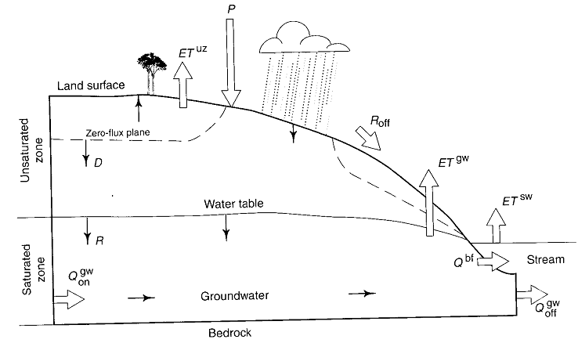
Figure 2 Schematic vertical cross section through a watershed showing water budget (Healy 2010).
Inflow is in the form of recharge and out flow is by groundwater flow, evapotranspiration and baseflow (Healy 2010). The water budget analysis of the recharge area determines the natural recharge to an undeveloped aquifer by means of the following equation (Poehls et al. 2009).
Groundwater recharge = (precipitation + surface water inflow + imported water + groundwater inflow) – (evapotranspiration + reservoir evaporation + surface water outflow + exported water + groundwater outflow) ± changes in surface-water storage
The above equation accounts for groundwater recharge form precipitation, irrigation water, losing streams and unlined canals (Poehls et al. 2009).
- Modelling methods
Recharge simulation models are globally utilized in hydrological studies to estimate recharge and identify factors that influence recharge (Healy 2010). Most of these simulation models are based on a form of water budget equation and some of these models include the watershed models and groundwater flow models (Healy 2010). Great example of these models is the empirical models for estimating annual groundwater recharge based on the functions such as precipitation, climatic data or watershed characteristics without involving the water budget equation (Healy 2010).
3.1 Unsaturated zone water budget models
Diffused recharge is a form of recharge that occurs as water moves through the unsaturated zone to the aquifers beneath (Healy 2010). The saturated zones water budget models are commonly used to predict the diffuse recharge in the unsaturated zone and common unsaturated zone water budget models are soil water budget models and models based on the Richards equation (Healy 2010).
3.1.1Soil water budget models
The soil water budget models comprise of two common components namely (Healy 2010):
- Soil or root zone component that estimates the amount of drainage through the base of the unsaturated zone
- Submodel component that transport the estimated drainage into the water table
The estimated drainage from the soil or root zone component is given by an equation (Healy 2010):
D = P – Et^{uz} - ∆S^{uz} - R_{off}
Where:
  - D is drainage
  - Et^{uz} is the evapotranspiration form the soil zone
  - ∆S^{uz} is the change in storage in the soil zone
  - R_{off} is the runoff
The estimation equation is valid for any time-step size but drainage estimation may be sensitive to time-step size and the equation also assumes that the maximum storage within the root zone is fixed and doesn’t vary with time (Healy 2010). The soil water budget models can be categorised into bucket or tank models and HELP3 models.
3.1.1.1Tank model
The model comprises of series of storage reservoirs referred to as buckets present in the surface and subsurface tanks, layers or compartments (Healy 2010).
Figure 3 Illustration of a simple tank model (Healy 2010).
The infiltration form precipitation or irrigation fills the shallowest subsurface bucket and excess water from the shallowest filled bucket flows into the next deeper buckets and so on (Healy 2010). There are various phenomena that extract water from the deepest bucket and there phenomena are evaporation, plant transpiration and interflow and water that flows into and out of the deepest bucket is regarded as recharge (Healy 2010).
3.1.1.2 HELP3 models
The model has been used in many recharge estimation studies and it allows users to select reasonable amount of layers and it gives a detailed data on physics of water movement and recharge by means of an equation (Healy 2010).
$R\left(t\right)=\int_{0}^{t}{I_{net}\left(t-τ\right)∅'\left(τ\right)dτ}$
Where:
  - R(t) is the cumulative recharge arriving at the water table between time 0 and t
  - Inet is the net infiltration or drainage based on the root zone
  - ᶲ’ is a linear transfer function
  - τ is time lag of the transfer function measured backwards in time form t
3.1.2 Models based on the Richards equation
The Richards equation models flow of water and provide a water movement simulation through the unsaturated zones (Healy 2010). There are many flow models which are based on the Richards equation including VS2DI, HYDRUS and UNSAT-H (Healy 2010). The equation estimates the time travel of wetting fronts moving from soil zone to the water table and also identifies physical features that can affect water movement (Healy 2010). The Richards equation is derived from Darcy equation and water movement conservation equation and is given by equation (Healy 2010):
$\frac{∂θ}{∂t}=\frac{∂K_{s}K_{r}\left(h\right)}{∂z^{2}}+Q'$
Where:
  - ϴ is the volumetric water content
  - K_{s} is the saturated hydraulic conductivity in vertical direction
  - K_{r} is the relative hydraulic conductivity
  - h is the pressure head
  - H is the total head
  - Q’ is the accounts for sources and sinks
  - t is time
  - z is vertical coordinate
3.2 Up scaling of recharge estimates
Up scaling of recharge estimates techniques are utilised for the development of parameter values for input to a hydrological model (Healy 2010). The most common and simplest up scaling point measurement procedure is to average all the data values and most of this procedure is based on the diffuse recharge estimation derived from methods such as stream flow hydrographs analysis (Healy 2010).
3.2.1 Simple empirical models
Simple empirical model is a recharge estimation model by assuming the recharge to be equivalent to a fraction “a” of annual precipitation (P) and its equation is given by (Healy 2010):
R = aP
This is one of the simplest and widely used approach of recharge estimation; where the ration between the annual recharge and precipitation serves as parameters that allow comparison of recharge rates from different time span and regions with a ratio range of 0.02 to more than 0.5 (Healy 2010). Factors that influence the annual recharge and precipitation ratio include the depth to the water table (Healy 2010). Simple empirical model was modified into an equation:
R = 0.03P1 + 0.07P2 + 0.15P3 + 0.25P4
Where:
  - R is the volume of annual recharge for the watershed
  - P1 is the precipitation volume in zones where precipitation is between 203 and 305mm
  - P2,P3 and P4 are volumes for zones where precipitation is between 305 and 381mm; 381 and 490mm and over 490mm
The modified empirical model equation assumed groundwater recharge to be equivalent to the discharge (Healy 2010).
3.2.2 Power function model
Power function model was firstly used by Keese et al. (2005) to estimate the annual recharge from mean annual precipitation and the equation is given by (Healy 2010):
R = aP^{b}
This estimation equation provides much reliable and better results than a general simple empirical mode equation (Healy 2010). The precipitation in the power function model exceeds the threshold replaced by precipitation (Healy 2010).
3.2.3 Regression techniques
Regression technique is a multitude hydrological study for purpose of extrapolating or up scaling of recharge estimations in space or extension of the estimates in time (Healy 2010). The linear regression equation is given by (Healy 2010):
R = aX₁ + bX₂ + c
Where:
  - a, b and c are coefficients determined by regression analysis
  - X₁ and X₂ are independent parameters that reflect watershed characteristics
The regression equation is derived from measured recharge data such as estimates of diffuse recharge derived from analysis of stream flow hydrographs (Healy 2010).
3.2.4 Geostatistical techniques
If point estimates of recharge are available at other fixed locations within the watershed, Kriging interpolation method can be useful for estimating recharge at any location in a watershed (Healy 2010). Kriging method is done by constructing a grid over a watershed and determines kriged estimates of recharge at each grid point and the entire watershed (Healy 2010). The uncertainity of interpolated values can be measured and the recharge estimation is calculated using a linear combination of all available data values using an equation (Healy 2010):
$R^{*}=\sum_{k=1}^{N_{obs}}{λ_{k}R_{k}}$
Where:
  - N_{obs} is the number of points where recharge is known
  - R_{k} is a recharge value location K
  - λ_{k} is kriging weight associated with each data location
Kriging method can be extended into cokriging, which allows more than one data type in the estimation process (Healy 2010).

- Unsaturated physical models

Unsaturated physical model are recharge estimating models based on the measurements of groundwater levels over time and space, for example, the zero-flux plane method and lysimetry (Healy 2010).

  - Zero-flux plane method (ZFP)

Zero flux plane is a subsurface horizontal plane at an unsaturated zone where the magnitude of the vertical hydraulic gradient is zero (Healy 2010).
Figure 4 Illustration of ZFP with soil column extending from the surface to the groundwater with different component (Healy 2010).
Water above the ZFP moves vertically upwards due to the evapotranspiration demand of the atmosphere and water below the ZFP drains downwards to recharge the aquifer (Healy 2010). The maximum depth of rooting although suction exerted by roots may draw water from beneath their maximum depth is ZFP (Healy 2010). The determination of ZFP can lead to the estimation of drainage and evapotranspiration by measurements of change in the water storage within the unsaturated zone over time (Healy 2010). The ZFP method was proposed by Richards et al. (1956) and is applied over a control volume consisting of discrete depth interval of unsaturated zone (Healy 2010).

  - Lysimetry
Lysimetry is a container filled with soil and placed in the field to mimic the surrounding soils and vegetation for purpose of studying the atmosphere, soil, and water and plant interaction with the natural and artificial conditions (Healy 2010).
Figure 5 illustration of Lysimetry curve with free drainage at the bottom (Healy 2010).
The Lysimetry can also be used to measure leaching and percolation of solutes through the soil and can also provide direct measurements of drainage through unsaturated zone and evapotranspiration (Healy 2010). The Lysimetry is weighed at regular intervals to gather information for studies of evapotranspiration and rate of change in water storage (Healy 2010). Lysimetry covers a surface area of about 0.1 m2 to more than 100m2 and the water that drains out the bottom of the Lysimetry is a component of recharge interest (Healy 2010).
  - Cumulative rainfall departure
The cumulative rainfall departure is based on the water level changes that are caused by rainfall events (Xu et al. 2003). The method was modified to include trends in rainfall time series and is given by an equation (Xu et al. 2003):
$R_{T}=rCRD_{i}=S_{y}\left[{Δh}_{i}+\left(Q_{pi}+Q_{outi}\right)/\left({AS}_{y}\right)\right]$ With
${CRD}_{i}=\sum_{i=1}^{N}{P_{i}-\left(2-\frac{1}{P_{av}i}\sum_{i=1}^{N}{P_{i}}\right)}{iP}_{t}$
Where:
  - r is that fraction of a CRD which contributes to recharge
  - S_{y} is specific yield
  - ∆h_{i} is water level change during month i (L)
  - Q_{p} is groundwater abstraction (L³/T)
  - Qout is natural outflow
  - A is recharge area (L²)
  - P_{i} is rainfall for month i (L/T)
  - P_{t} is a threshold value representing aquifer boundary conditions
4.3.1 Limitations
The CRD method only applies in areas with groundwater level fluctuations and the equations above, only apply to unconfined aquifers (Xu et al. 2003). The method requires regular rainfall records, water levels, borehole abstractions and aquifer properties, storativity and recharge area size (Xu et al. 2003).
4.3.2 Method ratings
The CRD method is easy to apply, accurate and cost effective with water level simulation based on the method (Xu et al. 2003). The increase in the depth of water table increases the uncertainty in recharge estimation (Xu et al. 2003).
Other unsaturated physical models of estimating groundwater recharge include the unsaturated flow modelling and the extended model for aquifer recharge and moisture transport through unsaturated hard rock (Xu et al. 2003).
- Saturated physical models
A saturated physical model is a recharge estimating model based on the measurements of groundwater levels over time and space, for example, the water table fluctuation method which estimate recharge by use of fluctuations of groundwater levels over time for unconfined aquifers (Healy 2010).
  - Water table fluctuation method (WTF)
Recharge water arriving at the water table cause the premise that rise in the groundwater levels of unconfined aquifers based on the water table fluctuation method (Healy 2010).
Figure 6 Diagram that illustrate different water table level elevations (Healy 2010).
WTF method assumes that the specific yield times the height of water in the column unit is equivalent to the amount of available water in a column of unit surface area and the recharge equation is given by (Healy 2010):
∆S^{gw} = R = S_{y}∆H/∆t
Where:
  - S_{y} is a specific yield
  - ∆H is a change in water table height over time interval ∆t
The assumptions given by the derived recharge equation state that the water arriving at the water table goes to the storage immediately and all components of recharge equation are zero during recharge period (Healy 2010). The recharge equation generate an estimation of total or gross recharge by setting the change in water table height over time to be equivalent to the difference between the peak of rise and low point of the extrapolated antecedent recession curve at the time of the peak (Healy 2010).
Figure 7 Illustration of water table fluctuation with time (Healy 2010).
The recharge equation can also be utilised to calculate the net change in saturated zone surface storage and parameter ∆H is replaced with ∆H_{n}, which is the difference in head between the end and start of time interval as shown in the figure above (Healy 2010).
5.2 Water balance method
Is a recharge amount and rate estimation method to aquifer and other parameters such as precipitation, evapotranspiration, surface runoff, pumping, discharge, and interﬂow are also estimated and the relationship between these parameters is derived from a simple mass balance concept (ASTM 2001). Water balance equation is given by the equation (ASTM 2001):
R = P + I – ET + Sr_{on} – SR_{off} + L_{on} – L_{off} – ∆S
Where:
  - R = recharge rate or soil-moisture ﬂux below the root zone [L/T],
  - P = precipitation rate [L/T],
  - I = irrigation water application [L/T],
  - ET = evapotranspiration rate [L/T],
  - Sr_{on} = surface water runon [L/T],
  - Sr_{off} = surface water runoff [L/T],
  - L_{on} = interﬂow (water laterally entering the zone of interest) [L/T],
  - L_{off} = interﬂow (water laterally leaving the zone of interest) [L/T], and
  - ∆S = change in soil moisture storage [L/T]. The water balance equation is then solved for the recharge rate.
Other saturated physical methods for estimation of groundwater recharge include the saturated volume fluctuation and the equal volume spring flow
- Surface water physical models
6.1 Groundwater modelling
Groundwater modelling predicts the aquifer piezometry under various groundwater stress situations by means of a general 3D groundwater flow equation, which assumes uniform fluid density and viscosity (Xu et al. 2003). Groundwater modelling equation is given by:
$\frac{∂}{∂_{xi}}\left(K_{ij}\frac{∂h}{∂_{xj}}\right)+q_{s}=S_{s}\frac{∂h}{∂t}$
Where:
  - i,j represent principal coordinate directions,
  - K is hydraulic conductivity tensor (L/T),
  - h is hydraulic head (L),
  - S_{s} is specific storage (1/L),
  - x is a space coordinate (L),
  - t is time (T) and
  - q_{s} Represents fluid sources (such as recharge) or sinks (such as abstraction) per unit volume (1/T)
From the groundwater modelling equation, recharge can be calculated if piezometry, K and S parameters are known, together with the inflow (e.g. riverbank infiltration, inter-aquifer flow, etc.) into and outflow (natural drainage, abstraction, evapotranspiration) from the aquifer (Xu et al. 2003).
6.1.1 Limitations
This method is time consuming, difficult to calibrate and is sensitive to boundary conditions (Xu et al. 2003).
6.1.2 Data requirements
There are various requirements for the model to run; these include the conceptual hydrological model, regular rainfall records, water levels records, borehole abstraction records, storativity, hydraulic conductivity, porosity, dispersion characteristics and radio-nuclide concentrations (Xu et al. 2003).
6.1.3 Model ratings
Recharge estimation accuracy relates to the degree of discretization of groundwater and parameter values (Xu et al. 2003). Higher degree of confidence on the recharge estimation is gained if the velocity distribution in an aquifer is based on the flow model is similar to the age distribution of groundwater (Xu et al. 2003).
- Climate impacts on groundwater recharge
When excess large rainfall events of the recharge threshold exist can lead to groundwater recharge (Baker 2007). Frequency and timing of recharge events altering groundwater recharge regimes can be potentially influenced or changed by change in the climatic condition (Baker 2007). Knowledge about the influence of climatic change on the groundwater recharge requires an understanding of rainfall events changes (Baker 2007).

- Summary of groundwater recharge estimation methods
Table 1 Recharge estimation methods applied in (semi-)arid Southern Africa (Xu et al. 2003).
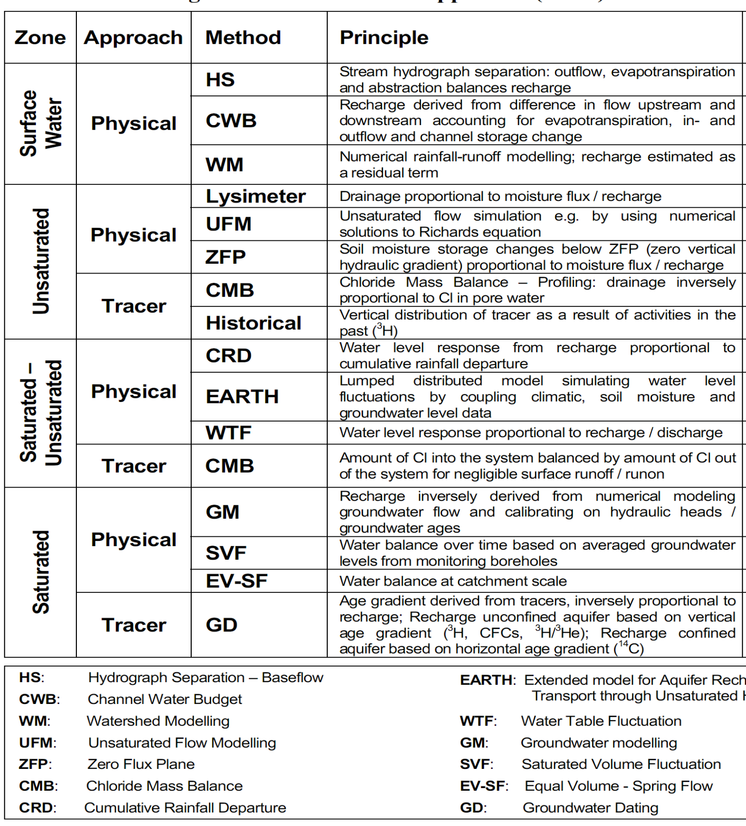
- Conclusion
Recharge is an addition of water to the saturated zone either through natural or artificial means and the amount in natural recharge being controlled by factors such as precipitation after runoff, vertical hydraulic conductivity, transmissivity of aquifers and vertical infiltration through vadose zone etc. Water budget equation balances groundwater record and it accounts the annual recharge to the groundwater resource and is needful for the management and utilization of water resource in groundwater development programmes. Recharge simulation models are globally utilized in hydrological studies to estimate recharge and identify factors that influence recharge. These models are divided according to different zones namely; surface water, saturated and unsaturated zone. Through all the zones there are different methods that can be used to estimate recharge and some of these methods include saturated water budget models ( HELP3, tank or bucket model), models based on the Richards equation, up scaling of recharge estimates (simple empirical models, power function models, regression techniques and geostatistical techniques), the unsaturated physical models (zero-flux plane method (ZFP), lysimetry and cumulative rainfall departure), the saturated physical models (water balance method and water table fluctuation method) and the surface water physical models (groundwater modelling).
- References

- ASTM .(2001). Standard Guide for Comparison of Techniques to Quantify the Soil-Water (Moisture) Flux. ASTM International, United States. Designation: D 6642 – 01
- Baker, P. (2007). Groundwater recharge. Bureau of Rural Sciences: Australia. pp 1-8. [Available online]: www.brs.gov.au/shop
- Le Maitre, D.C, and Colvin, C.A. (2008). Assessment of the contribution of groundwater discharges to rivers using monthly flow statistics and flow seasonality. South Africa: Natural Resources and Environment CSIR.Water SA Vol. 34: 549-564.
- Orpen, W.R.G. (1992). Artificial recharge of ground water in the RSA. Borehole Water Journal, Vol 24: 12-16.
- Poehls, D.J. and Smith, G.J. (2009).Encyclopedic Dictionary of Hydrogeology. Elsevier, London. Pp1-527
- Rushton, K.R and Ward, C. (1979). Journal of Hydrology: The estimation of groundwater recharge. Amsterdam, The Netherlands. 41:345-361
- Wright, A. (1991). Groundwater: The key to life for a West Coast Town. Borehole Water, Vol 20: 6-9
- Xu, Y and Beekman, E.H. (2003). Groundwater Recharge Estimation in Southern Africa. UNESCO Paris: Cape Town. Pp1-206. [Available online]: http://www.unesco.org/water

