university of pretoria
Discuss the use of magnetic methods in engineering geological surveys
Department of Geology
Sedzani Elia Muravha
2/20/2012

Abstract The use of magnetic methods started late 1600s and is still applied today in engineering geological surveys and other common related fields. To understand the application of magnetic methods for engineering geological surveys one should understand the properties of magnetics first. The magnetic field of the Earth, magnetic survey, different equipments and application is important in engineering geological surveys.

Contents
Introduction………………………………………………………………… 3
History…………………………………………………………………… 3
Magnetic properties of engineering geological features………………… 3
- Poles, dipoles and magnetization………………………………………………… 4
- Susceptibility……………………………………………………………………… 4
- Remanence……………………………………………………………………… 4
- Susceptibilities of rocks and minerals…………………………………………… 4
The geomagnetic field…………………………………………………… 5
Field operation magnetic survey in engineering geology………………… 5
- Airborne Magnetic Surveys…………………………………………………… 5
- Shipborne Magnetic Surveys…………………………………………………… 7
- Ground Magnetic Surveys………………………………………………………… 7
Instruments for magnetic survey…………………………………………… 7
- Proton precession magnetometer………………………………………………… 7
- High sensitivity (alkali vapour) magnetometers………………………………… 7
- Fluxgate Magnetometer…………………………………………………………… 8
- Gradiometer……………………………………………………………………… 8
Application of magnetic methods in engineering geological survey……… 8
- Applying Magnetics……………………………………………………………… 8
- Magnetic methods in detection of natural cavities and mineshafts……………… 9
- Magnetic Markers……………………………………………………………… 9
- Pipelines ………………………………………………………………………… 9
Conclusion ……………………………………………………………… 10
References………………………………………………………………… 11

Introduction
Magnetic method is a type of geophysical surveying method that investigates and measures the subsurface and surface geological variations of magnetization on the basis of anomalies in the Earth’s magnetic field to produce the magnetic properties of the underlying rocks, minerals and ores, and other subsurface engineering features such as abandoned mineshafts, sink holes, and buried services, etc. Most rock-forming minerals are effectively non-magnetic, therefore to generate a magnetic anomaly the availability of sufficient magnetic minerals should be available to record anomaly. The magnetization intensity and intensity in which the Earth’s magnetic fields is changed depends on the magnetic susceptibility of the ore, mineral or rock under the investigation. The potential application of magnetic methods in engineering geological surveying is mapping subsurface voids, bedrock topography, steeply dipping geological contacts, regions of potential stress amplitude (e.g. plutons and fault zones irregularities), potential zones of weakness (e.g. paleorifts, sutures, and faults), landfills, archeological sites (buried ferromagnetic objects, fire beds, burials, etc.) etc. The magnetic surveys can performed in different places such as sea, on land and air. The main focus of the report is to discuss the use of different magnetic methods in engineering geological surveys. Aspects such as magnetic properties of engineering geological features, the geomagnetic field, field operation magnetic survey, instruments of magnetic survey, interpretation and measurement of the magnetic anomalies are of good importance in engineering geological surveys.

History

The concept of magnetism is an improving and useful issue today, however, this concept has a very long and interesting past since it began. The magnetic concept arose in the year 1600 through a publication of a book De Magnete by a physician named William Gilbert (Parasnis 1972). The local anomalies of the Earth’s magnetic field orientation observations were firstly used in Sweden for iron-ore prospecting in the 1640s (Parasnis 1979). In the late 1870s, Thalen and Tiberg constructed their rapid and accurate force determination magnetometer (Parasnis 1972). Magnetic measurements for investigations of geological and engineering geological structures in large scale began to develop more in the 1915s (Parasnis 1979). Magnetic methods is a common geophysical methods used today in geology and engineering geology in locating buried hills, geological faults, intrusions of igneous rock, salt domes associated with oil fields, concealed meteorites and buried magnetic objects such as pipe-lines, etc (Parasnis 1979).

Magnetic properties of engineering geological features

All geological structures, rocks, minerals, ore deposits and engineering geological structures have magnetic properties that differ by orders of magnitude rather than percentages (Milsom 2003). The intensity of magnetization in engineering geological structures are accurately determined by measuring the anomalies produced by any particular structure (Parasnis 1972). Magnetization of any structure is due to induction in the geomagnetic field and permanent magnetization (remanent) (Parasnis 1972). The induced magnetization intensity depends on the poles, dipoles and magnetization, susceptibility, remanence, susceptibilities of rocks and minerals (Milsom 2003).

Poles, dipoles and magnetization

The inverse-square law should be obeyed by any isolated magnetic pole producing magnetic fields (Milsom 2003). The dipole is the fundamental magnet source and produces same effect as positive and negative pole (Milsom 2003). A dipole has magnetic moment, which plays an important role of dipole rotation when exposed to magnetic field (Milsom 2003).

Susceptibility

Magnetic susceptibility is the degree to which rocks, minerals, ores or a certain body is magnetized (Clayton et al.1995). Susceptibility can either be negative (diamagnetism) or positive (paramagnetism) and in most natural material is very small (Milsom 2003). The intermolecular exchange forces held the molecular magnets parallel in ferromagnetic substances and below Curie temperatures ( about 600 0C) these forces are strong enough to sustain the effects of thermal agitation (Milsom 2003). Ferromagnetic bodies contain minerals such as magnetite, pyrrhotite and maghemite (Milsom 2003).

Remanence

Remanence magnetism is the residual magnetism or natural remanence magnetization which forms part of net magnetization in an object (Telford et al. 1990). The residual magnetism depends on the magnetic history of an object and may be caused by, Thermoremanent magnetization, Detrital magnetization, Chemical remanent magnetization, Isothermal remanent magnetization and Viscous remanent magnetization (Telford et al. 1990).

Susceptibilities of rocks and minerals

The magnetic susceptibilities commonly depends on the content of magnetism presence in the rock (Milsom 2003).
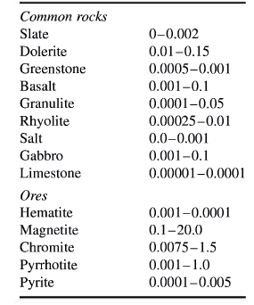
Table 1 Magnetic susceptibilities of common rocks and ores (Milsom 2003).

Table 1 shows different magnetic susceptibility of common rocks, where acidic igneous rocks have smaller susceptibilities compared to rocks like basalts, dolerites, gabbros and serpentinites (Milsom 2003).

The geomagnetic field

The production of an anomaly map from magnetic field data requires knowledge of the Earth’s magnetic field is space and time in the area of the engineering geological survey (Griffiths and King 1981).
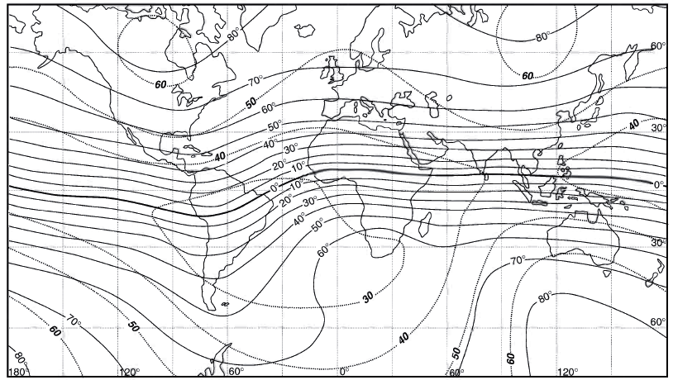
Figure 1 Dip (continuous lines, values in degrees) and intensity (dotted lines, values in thousands of nT nanoTesla) qf the Earth's magnetic field. The thick continuous line is the magnetic equator (Milsom 2003).

Field operation magnetic survey in engineering geology
Magnetic surveys for engineering geological purpose can be performed on land, airborne or Shipborne (Hinze 1990). There are different magnetic surveys that can be applied for engineering geological purposes.

Airborne Magnetic Surveys
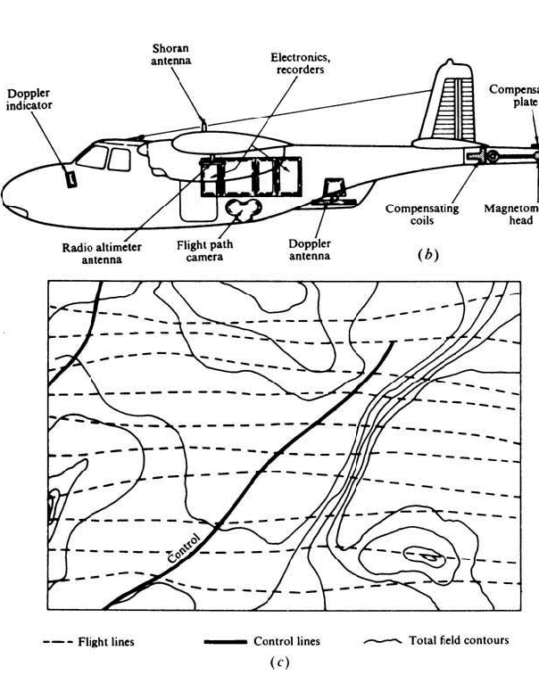
Figure 2 airborne magnetic. (b) Magnetometer in a tail mounting. (c) Flight pattern and magnetic map (Telford et al. 1990).
Figure 2 shows a plane with a magnetometer mounted at the tail for surveying purposes to produce a magnetic map. Airborne or aeromagnetic surveys are very fast and easy to do, cost-effective as compared to other geophysical techniques (Kearey et al. 2002). Airborne flight tows a housing known as a ‘bird’ with magnetometer at the tail to remove the instrument from the magnetic effects of the aircraft (Kearey et al. 2002). Aeromagnetic surveys can be performed for engineering geological surveys for mapping and locating different geological features (Hinze 1990). It can be used to locate small and large engineering geological features such as buried well casings, drams, pipelines, locating coal bums, underwater ferromagnetic objects, sand and gravel deposits that contain heavy minerals( including magnetite) (Hinze 1990). Aeromagnetic surveying method can be useful in engineering geological mapping of subsurface voids (natural cavities), bedrock topography, steeply dipping geologic contacts, regions of potential stress amplification (e.g. plutons and fault zone irregularities), potential zones of weakness (e.g. paleorifts, sutures, and faults), landfills, archaeological sites (buried ferromagnetic objects, fire beds, burials, etc.) (Hinze 1990).

Shipborne Magnetic Surveys
Shipborne is a type of magnetic survey performed on the water for geological and engineering geological purposes. The sensor in shipborne magnetic survey is towed in a ‘fish’ at least two ships’ lengths behind the vessel to remove its magnetic effects during the survey (Kearey et al. 2002). Shipborne surveys can be applied in large-scale oceanographic surveys, petroleum search and in plate tectonics (Telford et al. 1990).
Ground Magnetic Surveys
This is a type of magnetic survey that performed on the ground or on land. Ground magnetic surveys are performed over small areas, with station spacing of 10-100m (Kearey et al. 2002). The main application is in detailed survey for minerals, geochemical reconnaissance in base-metals search (Telford et al. 1990). Application in engineering geological surveys for mapping and locating buried well casings, pipelines, locating coal bums, sand and gravel deposits that contain heavy minerals( including magnetite), mapping of subsurface voids (natural cavities), bedrock topography, steeply dipping geologic contacts, regions of potential stress amplification (e.g. plutons and fault zone irregularities), potential zones of weakness (e.g. paleorifts, sutures, and faults), landfills, archaeological sites (buried ferromagnetic objects, fire beds, burials, etc.) (Hinze 1990).

Instruments for magnetic survey

Since 19th century different field magnetic instruments which are capable to measure the geomagnetic elements have been designed (Kearey et al. 2002). In geophysical surveys, engineering geological surveys, etc. there are different types of instruments that are used, most these instruments include proton precession magnetometer, high sensitivity (alkali vapour) magnetometers, fluxgate magnetometer, optically pumped magnetometer, gradiometer, etc.
Proton precession magnetometer
Is an instrument designed to give direct reading of the field strength by use of the hydrogen nucleus (proton) (Griffiths and King 1981) and (Milsom 2003). This instrument gives absolute measurements of the net magnetic field from any engineering geological feature accurate to 0.1 nT (nanoTesla) (Kearey et al. 2002). Problems like incorrect calibration are not experienced and inherently it is drift free (Griffiths and King 1981) and this instrument requires no leveling (Parasnis 1972). The main disadvantage of the instrument is the measurement of only the total field (Telford et al. 1990).

High sensitivity (alkali vapour) magnetometers
Is a type of magnetic instrument with high sensitivity and commonly used for airborne observation of the total magnetic field (Hinze 1990). High sensitivity (alkali vapour) magnetometers uses the radio-frequency and record the variation of magnetic frequency when the cell once again absorbs light (Milsom 2003 and Hinze 1990). Is also known as Optically pumped magnetometer.
Fluxgate Magnetometer
The fluxgate magnetometer is a continuous reading instrument which measures the change in the earth's magnetic field and is sensitive to magnetic field gradients along the length of the cores and is directionally dependent (Kearey et al. 2002) and (Hinze 1990). Fluxgate magnetometer cannon measure absolute fields and The instrument may be temperature sensitive, requiring correction and other disadvantages include inherent unbalance in the two cores, thermal and shock noise in cores, drift in biasing circuits (Telford et al. 1990), (Kearey et al. 2002) and (Milsom 2003). This instrument is commonly used in data loggers, archaeological surveys, geological surveys, etc. (Milsom 2003).

Gradiometer
Magnetic gradiometers are type of magnetometer in which the spacing between the sensors is fixed and small with respect to a magnetic body under measurements (Kearey et al. 2002). Magnetic gradiometers can be employed in shallow magnetic features survey to study near surface anomalous sources (Hinze 1990). The advantage of the method is that the regional and temporal variations in the geomagnetic field are automatically removed (Kearey et al. 2002).

Application of magnetic methods in engineering geological survey

There is a broad range for applying magnetic methods in engineering geological studies, from locating and characterizing voids in the earth and detection of buried objects such as metal containers that may contain hazardous waste to mapping engineering geological features that may pose hazards e.g. faults or any possible failure (Hinze 1990). Magnetic method is very easy to employ, fast and cheap (Hinze 1990).

Applying Magnetics

The application of magnetic methods in engineering geological surveys requires different step process from data acquisition to engineering geological interpretation (Hinze 1990).

The five principal steps follow.

- Acquire data in appropriate detail and precision
- Reduce data to interpretable form
- Identify and isolate anomaly
- Identification of source characteristics of anomaly
- Translate physical model into the engineering geologic model

The potential application of magnetic methods in engineering geological surveying is mapping subsurface voids, bedrock topography, steeply dipping geological contacts, regions of potential stress amplitude (e.g. plutons and fault zones irregularities), potential zones of weakness (e.g. paleorifts, sutures, and faults), landfills, archeological sites (buried ferromagnetic objects, fire beds, burials, etc.) etc. as shown in Table 2 below (Hinze 1990).

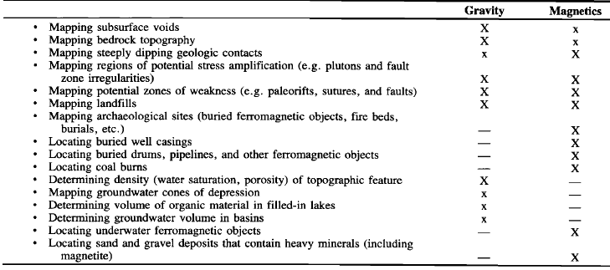
Table 2 Potential applications of gravity and magnetic methods in engineering and environmental studies (x-major; x-minor) (Hinze 1990).

Other useful applications in engineering geological survey is locating buried well casings, buried drams, pipelines, and other ferromagnetic objects, coal bums, underwater ferromagnetic objects, sand and gravel deposits that contain heavy minerals( including magnetite) (Hinze 1990).

Magnetic methods in detection of natural cavities and mineshafts

Natural cavities, voids of mineshafts appears as anomaly on the map showing variation of geomagnetic fields over a study area during engineering geological surveys (McCann 1987). Many natural cavities give rise to significant magnetic anomaly when they are filled with higher magnetic susceptible materials compared to the surrounding rock mass (McCann 1987). For an example, a cavity filled with clay can give rise to a magnetic anomaly that can be clearly identified on a magnetic map (McCann 1987).

Magnetic methods can be applied in locating buried mineshafts, more especially those with highly magnetic material or bricklined in-fill (McCann 1987). The main disadvantage of magnetic methods in locating mineshaft is when the in-fill material is similar in terms of magnetic properties with the surrounding rock mass (McCann 1987).

Magnetic Markers
Relocation of useful equipments or features over a long period can be determined using magnetic method (Breiner 1973).

Pipelines

Pipes contain very high permanent magnetization which produces a clear anomaly on the magnetic map that varies with length due to the thermal and mechanical history (Breiner 1973).
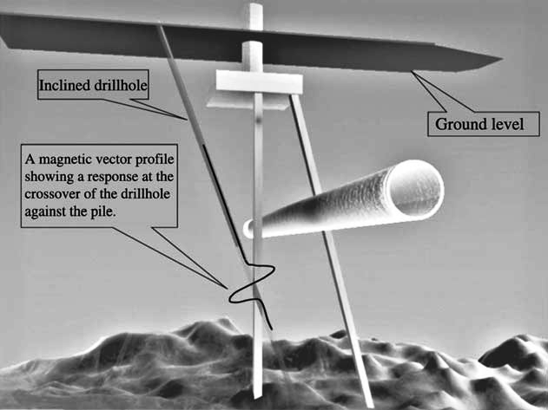
Figure An inclined drillhole against a vertical pile, with a simulated magnetic vector response at the crossover (Collar et al. 2005).
During the drilling of a vertically orientated hole for piles or any engineering purposes requires magnetic anomaly to detect any subsurface magnetic objects.

Conclusion
Magnetic methods are common geophysical technique used during different subsurface surveys such as engineering geological survey. The use of magnetic survey in engineering geological survey is mainly in mapping and locating engineering geological features. Features that can be detected during engineering geological surveys include, subsurface voids, bedrock topography, steeply dipping geological contacts, regions of potential stress amplitude, potential zones of weakness, landfills, archeological sites. The main features that are usually located for engineering geological purposes are buried well casings, buried drams, pipelines, and other ferromagnetic objects, coal bums, underwater ferromagnetic objects, sand and gravel deposits that contain heavy minerals, mineshafts, etc.

References
- Breiner, S. (1973). Application manual for magnetometers. Geometrics. USA.
- Clayton C.R.I., Matthews, M.C. and Simons, N.E. (1995). Site investigation: In situ testing. Department of Civil Engineering, University of Surrey. Second Edition. [Available online:] http://www.geotechnique.info/
- Collar, F., Fenning, P. and Mora, C. (2005). Application of drillhole vector magnetic measurements to resolve the position of existing underground structures. NDT&E International. China. 38: 231–236
- Griffiths, D.H. and King, R.F. (1981). Applied geopgysics for geologists and engineers. Pergamon Press. Oxford. -230.
- Hinze, W.J. (1990). The Role of Gravity and Magnetic Methods in Engineering and Environmental Studies. Geotechnical and environmental geophysics. Vol I. Tulsa. OK.
- Kearey, P., Brooks, M. and Hill, I. (2002). An Introduction to Geophysical Exploration. Third edition. Blackwell Science Ltd. London. Pp. 1-281
- McCann, D. M., Jackson, P. D. and Culshawt, M. G. (1987). The use of geophysical surveying methods in the detection of natural cavities and mineshafts. Quarterly Journal of Engineering Geology. British Geological Survey. London20: 59-73
- Milsom, J. (2003). Field Geophysics: Chapter 3 Magnetic method. Third Edition. John Wiley & Sons Ltd England. Pp. 51-70
- Parasnis, D.S. (1972). Principles of Applied Geophysics. Second Edition. Champman and Hall Ltd. London. Pp. 1-214
- Parasnis, D.S. (1979). Principles of Applied Geophysics. Third Edition. Champman and Hall Ltd. London. Pp. 1-275
- Telford, w. M., Geldart, L. P. and Sheriff, R.E. (1990). Applied Geophysics: Chapter 3 Magnetic Methods. Second Edition. Press Syndicate of the University of Cambridge. New York. Pp. 62-86

